**WAGNER—**3rd of D – 12 before E

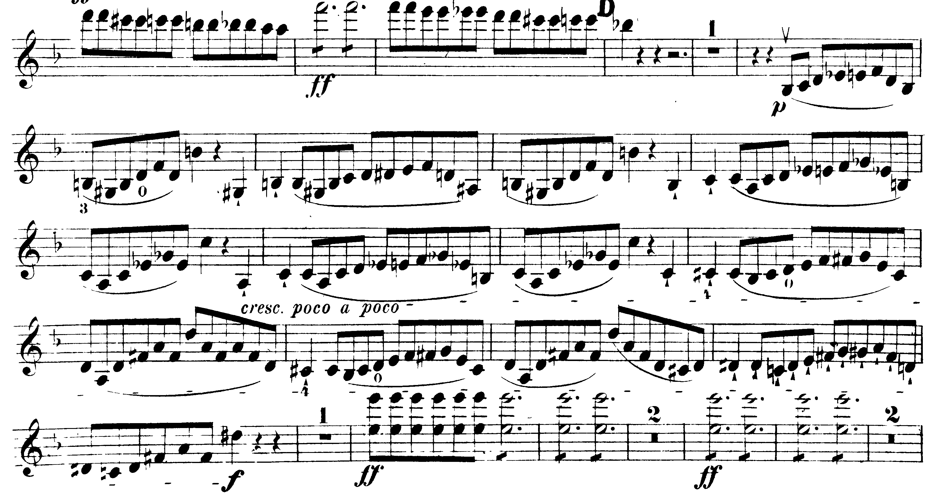

Letter K – Fermata

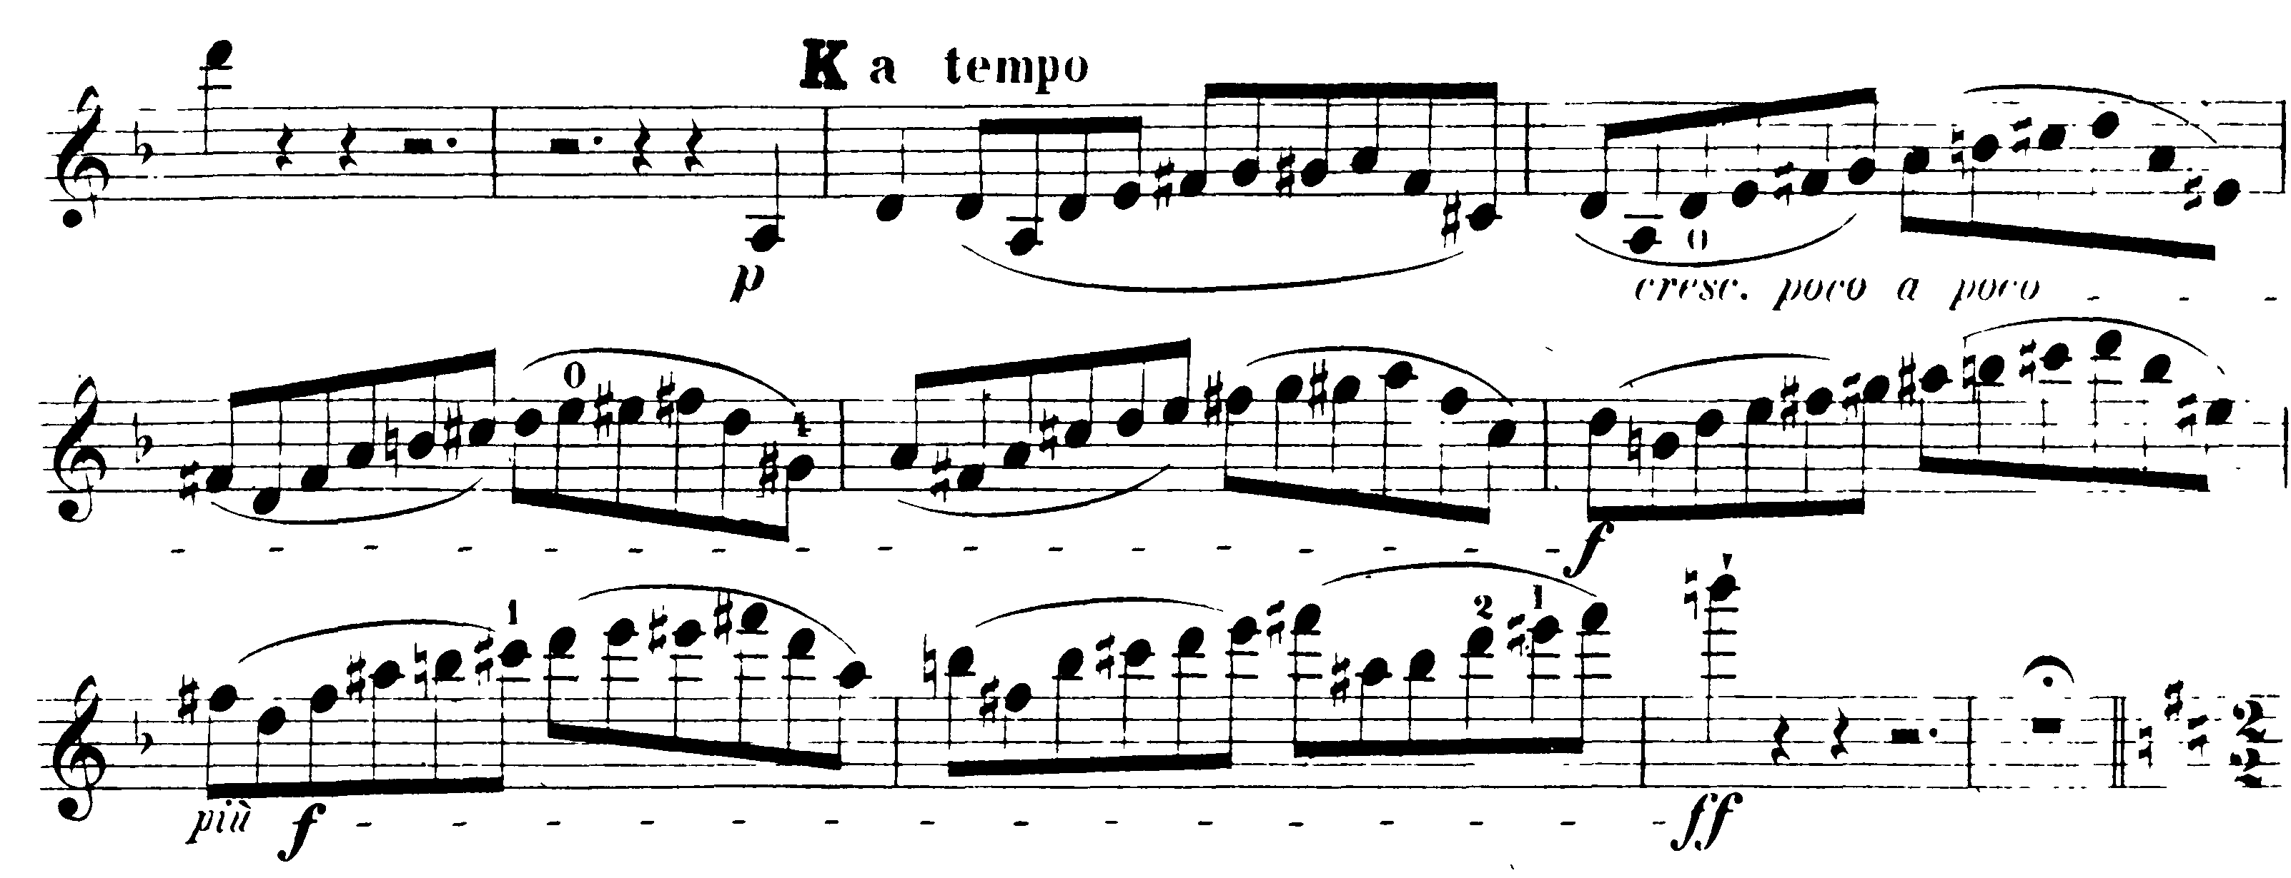

**TCHAIKOVSKY—**Mvt III: pick-up 73 – E 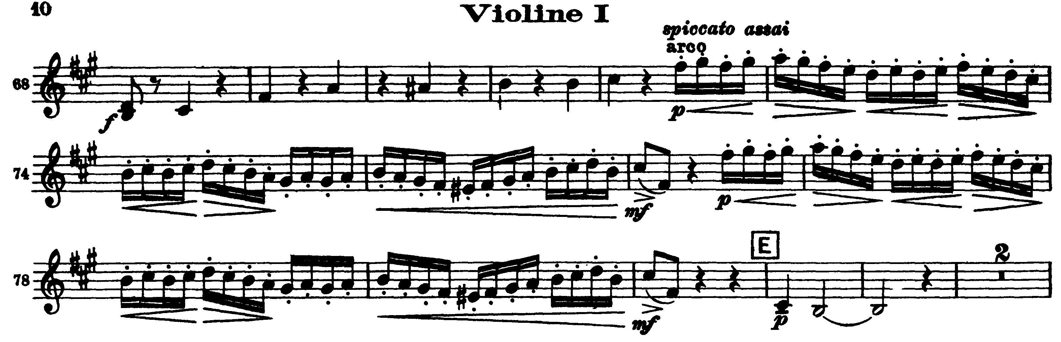

Mvt IV: Presto – Molto meno mosso

